Puthuvasantham Children’s Home
Best Student 2017-2018

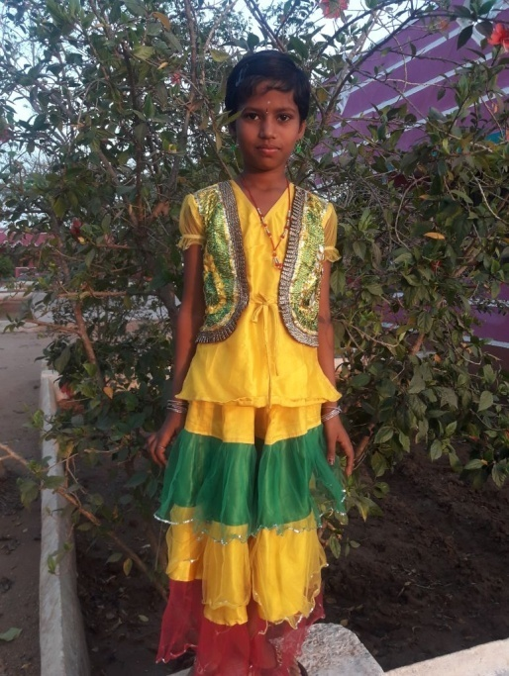
Inbasri – II Std
- Good at Dance
- Works well in job
- Hygienic
- Does well in studies
- Very active
P. Nagajothi – V Std
- Dance Well
- Does well in common work
- Excellent in Studies
- Very clean
- Good at drawing

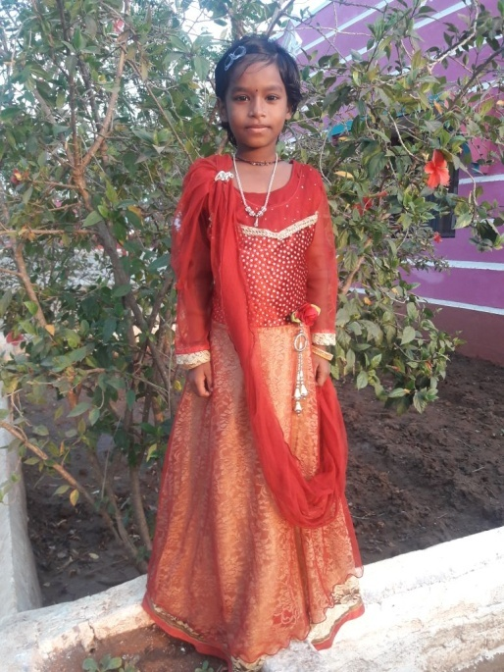

R. Hemalatha – V std
- Friendly in nature
- Very clean and tidy
- Excellent in her work
- Does well in her studies
- Punctual
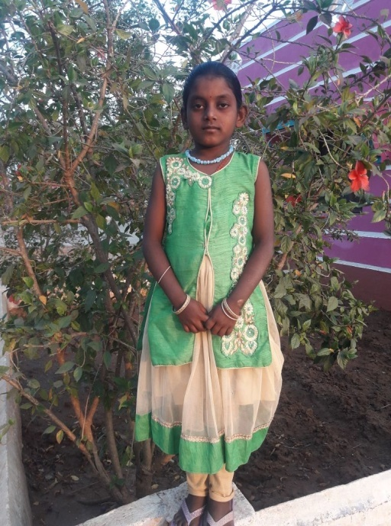
Kalaiselvi – IV Std
- Help others
- Hygenic
- Very active
- Excellent at Studies
- Does well in her work

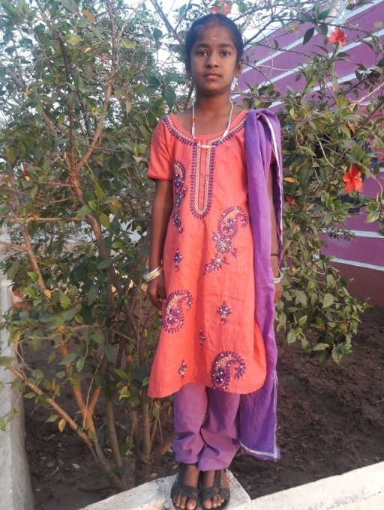

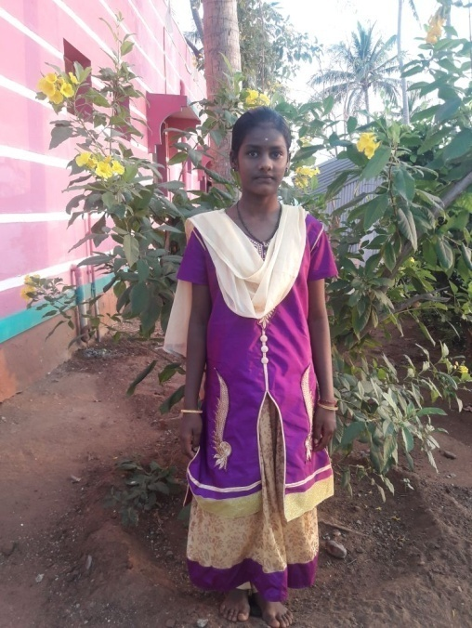
Kalaiyarasi – VI Std
- Draws well
- Very punctual
- Very responsible
- Very active
- Good at studies

- Yogeswari - VII Std
    - Good at singing
    - Excellent studies
    - Performs well in drawing
    - Commits to her work
    - very neat

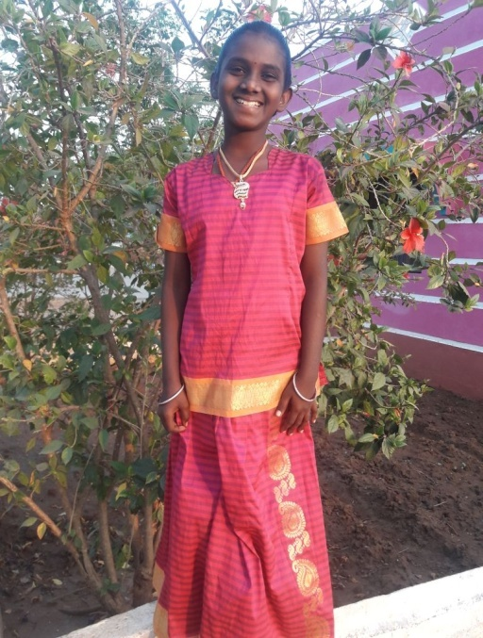

R. Karthika- VII Std
    - Very good dancer
    - Good a t drawing
    - Good at studies
    - very responsible
    - Keeps herself clean

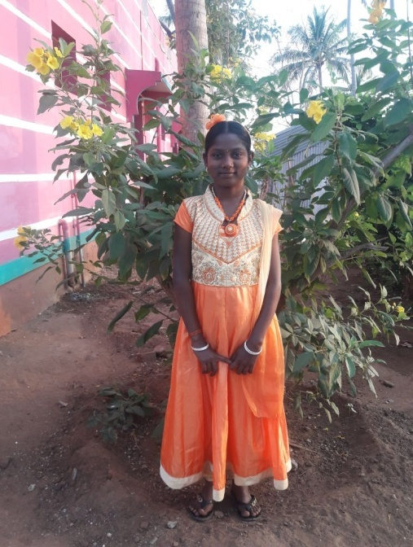

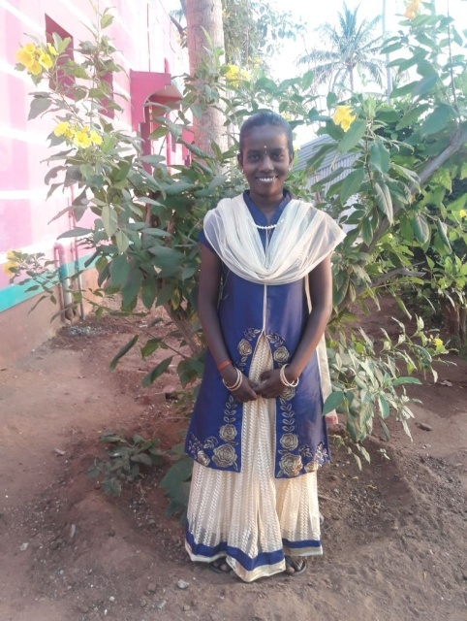
B. Kaviya - VIII Std
    - Good at Drawing
    - Very good leader
    - Keeps herself clean
    - Excellent in Studies
    - Good at dancing

R. Gayathri - IX Std
    - Very good studies
    - Excellent dancer
    - Helping habit
    - Neat and clean
    - Very good Leader

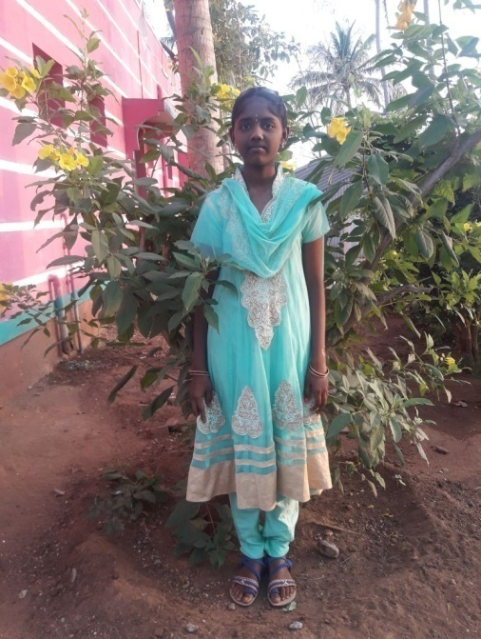

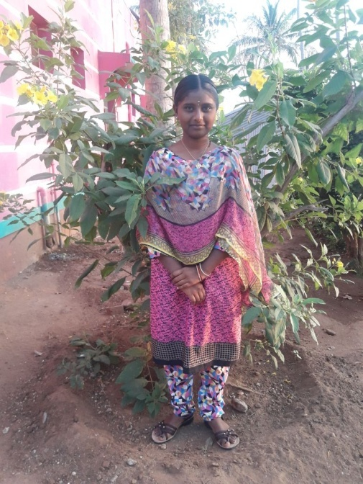
S. Hemalatha - X Std
    - Keeps herself neat and tidy
    - Very good at studies
    - Very loving child
    - Exhibits leader sip quality
    - Very good dancer

Puthu Udayam Special School & Hostel
Best Student 2017-2018

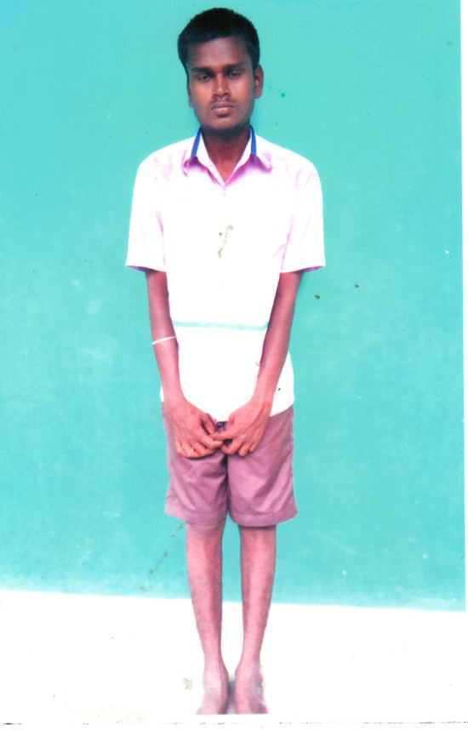
S. Karthick
- Very kind hearted
- Helps others
- Obedient
- Supports in maintaining the hostel

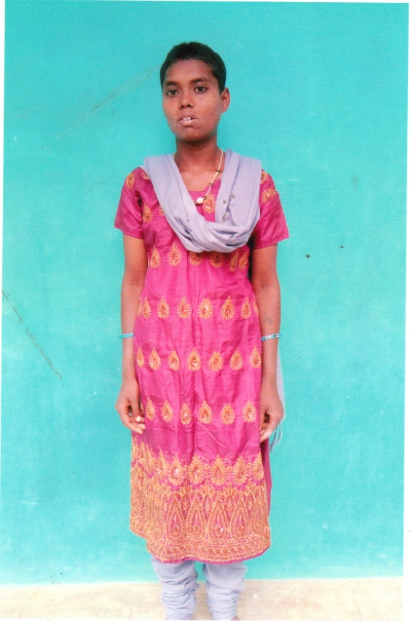

S. Santhiya
- Observes well
- Helps others
- Takes care of kids
- Obedient to the teachers

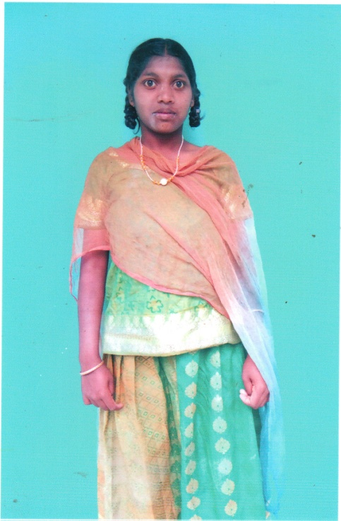
M. Bhavatharani
- Assists teachers in maintaining the records
- Loves and cares for the children
- Helps in washing the clothes of the children
- Very good dancer

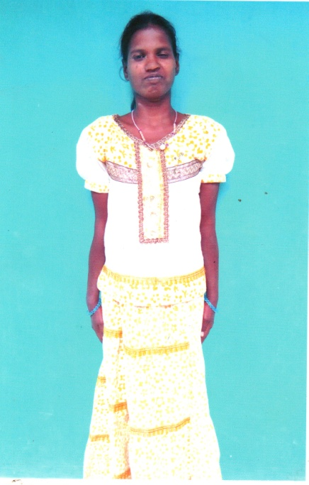

S. Rama
- Good at dancing
- Very responsible
- Holds responsibility in caring the children
- Helps wardens and teachers

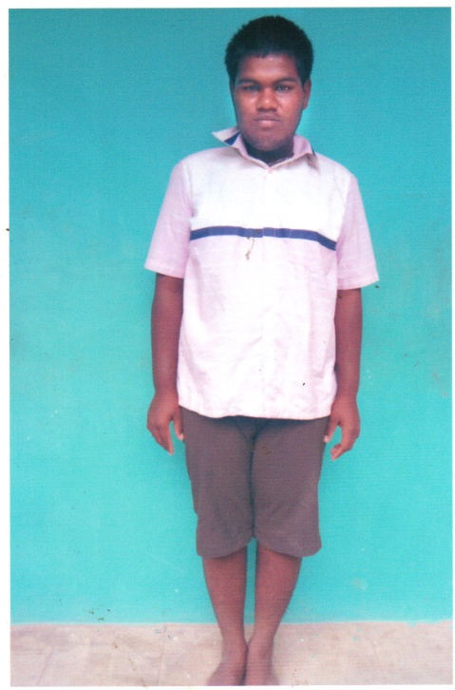
M. Prakash
- Cares for the children
- Helps in washing the clothes
- Obeys the teachers and wardens
- Interested in sports

Puthuirudayam Children’s Home
BEST STUDENT 2017 -2018

Puthupunal Children’s Home
BEST STUDENT 2017-2018

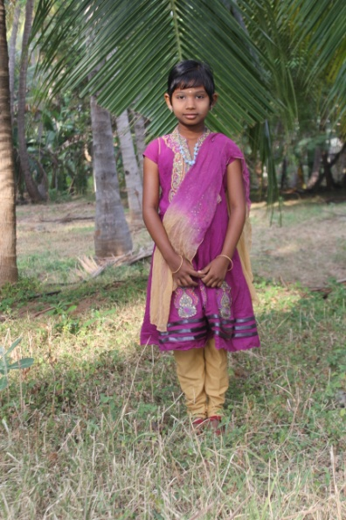
V. Vimala – I Std
- Very Quiet
- Good at Studies
- Obedient Girl
- Very calm in nature

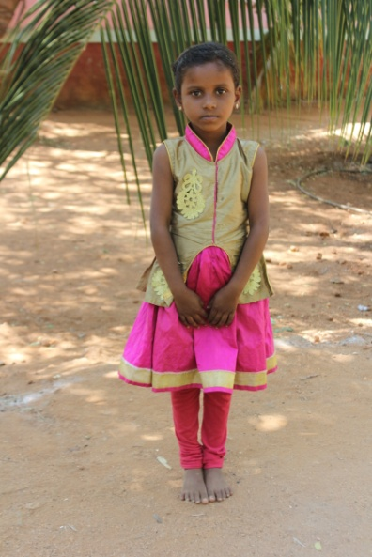

D. Harishma – I Std
- Very Calm in nature
- Excellent in Studies
- Obedient
- Very Talented

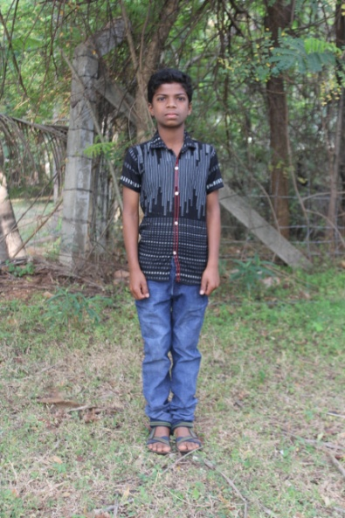

S. Alex Pandian – V Std
- Very Talented
- Responsible
- Obedient
- Enthusiastic

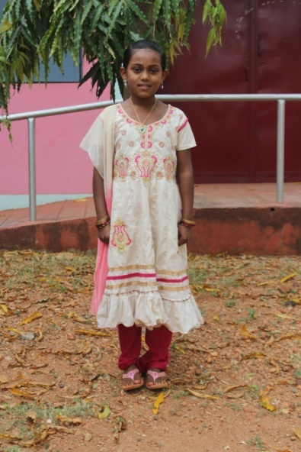
T. Tharika Devi – V Std
- Excellent speaker
- Responsible
- Obedient
- Calm and Quiet

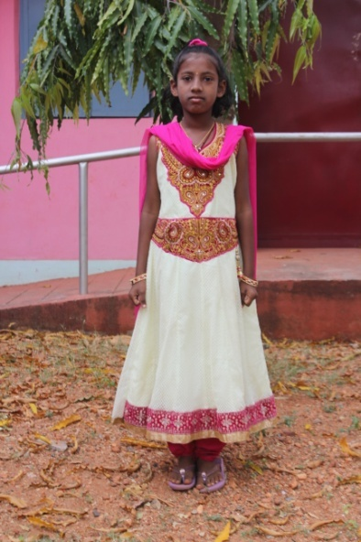

S. Shereya Devi – V Std
- Excellent in Studies
- Very good speaker
- Responsible
- Talented girl

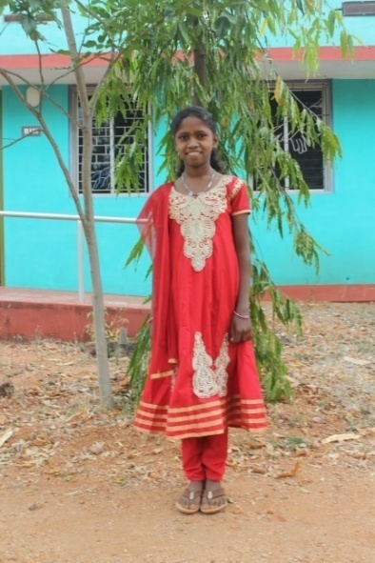
N. Kaleeswari – VI Std
- Very silent & Quiet in nature
- Very Talented
- Responsible
- Good at studies

- Obedient Girl

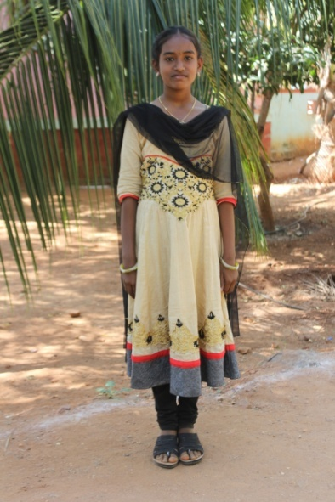

K. Vidhya – VII Std
- Good at studies
- Very silent in nature
- Disciplined
- Responsible

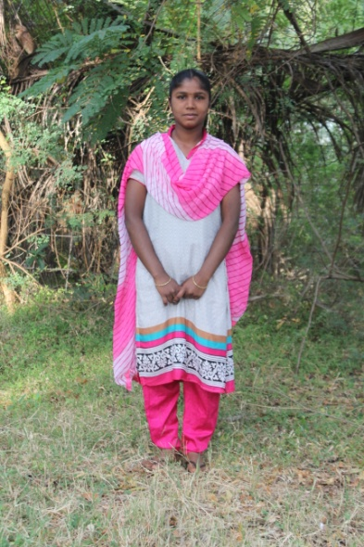
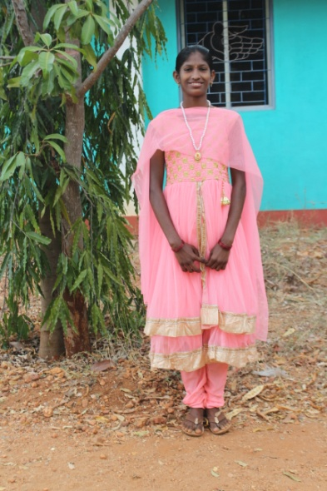
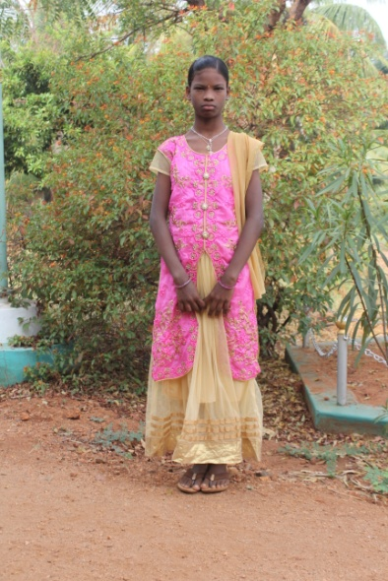
Pandiswari – XII Std
- Very loving in nature
- Responsible
- Very active and energetic
- Sacrificing
- Obedient
- Obedient Girl
G. Vennila – IX Std
- Very responsible
- Talented
- Enthusiastic
- Respectful

G. Ganga Priya – VIII Std
- Good at elocution
- Good at studies
- Respects others
- Talented girl

